|  |  |  |  |  |  |  |  |
| --- | --- | --- | --- | --- | --- | --- | --- |
| **REVISION HISTORY** | | | | | | | |
| **Rev.** | **Description of Changes** | | | | | **Date** | |
| -- | The document and revision history are maintained in ClearCase at: | | | | |  | |
| 1 | Initial draft | | | | | 09/04/17 | |
| 2 | Removal of installation references and pointing to Github repository | | | | | 04/16/19 | |
|  |  | | | | |  | |
|  |  | | | | |  | |
|  |  | | | | |  | |
|  |  | | | | |  | |
|  |  | | | | |  | |
|  |  | | | | |  | |
|  |  | | | | |  | |
|  |  | | | | |  | |
|  |  | | | | |  | |
|  |  | | | | |  | |
|  |  | | | | |  | |
|  |  | | | | |  | |
|  |  | | | | |  | |
|  |  | | | | |  | |
|  |  | | | | |  | |
|  |  | | | | |  | |
|  |  | | | | |  | |
|  |  | | | | |  | |
|  |  | | | | |  | |
|  |  | | | | |  | |
|  |  | | | | |  | |
|  |  | | | | |  | |
|  |  | | | | |  | |
|  |  | | | | |  | |
|  |  | | | | |  | |
| InterDigital_logo_BLACK_HiRes | | | | | | | |
| **APPROVALS** | | **name** | **DATE** | DOCUMENT TITLE |  | | |
| **EDITOR** | | Simon Pastor | 09/28/17 | Network Controller Orchestrator User Manual | | | |
| **MANAGEMENT** | |  | - |
|  | | | | DOCUMENT NUMBER |  | | Rev. |
| MA82841 | | | 2 |
| **© Copyright 2017 InterDigital Communications, LLC. All rights reserved**.  This work contains confidential and proprietary information supplied by InterDigital Communications, LLC and its subsidiaries (hereinafter, "InterDigital"). All such information is supplied on an “as is” basis without any warranty as to accuracy and expressly disclaiming all liability for errors or omissions. InterDigital reserves the right to modify this work and the information contained herein without notice. No part of this work may be reproduced, in whole or in part, except as authorized in writing by InterDigital, irrespective of the type of media in which the information may be embodied. InterDigital has the sole and exclusive ownership rights to this document and the information contained herein.  This document contains technology that is subject to U.S. export control laws and export administration regulations. Diversion contrary to U.S. law is prohibited. | | | | | | | |

Network Controller Orchestrator User Manual

Issued by:

InterDigital Communications, LLC [Corporate Headquarters]

200 Bellevue Parkway, Suite 300

Wilmington, DE 19809-3727

USA

+1 302.281.3600

[www.interdigital.com](http://www.interdigital.com)

This document was saved on 4/12/19 under the file name

Contents

[1 Introduction 5](#_Toc6387488)

[1.1 Overview 5](#_Toc6387489)

[1.2 Scope 5](#_Toc6387490)

[1.3 Abbreviations 5](#_Toc6387491)

[1.4 References 5](#_Toc6387492)

[2 Installation 6](#_Toc6387493)

[3 Usage 7](#_Toc6387494)

[3.1 Configuration page 7](#_Toc6387495)

[3.2 Customer Registration page 7](#_Toc6387496)

[3.3 Layout of a page 8](#_Toc6387497)

[3.4 Customer De-registration button 10](#_Toc6387498)

[3.5 Get Node Info page 10](#_Toc6387499)

[3.6 Get Maximum Available Bandwidth page 11](#_Toc6387500)

[3.7 Create Slice page 12](#_Toc6387501)

[3.8 Modify Slice page 14](#_Toc6387502)

[3.9 Get Slice Config page 14](#_Toc6387503)

[3.10 Delete Slice button 15](#_Toc6387504)

[3.11 Read Statistics page 16](#_Toc6387505)

[4 Appendix 18](#_Toc6387506)

[4.1 Bandwidth Allocation Design 18](#_Toc6387507)

[4.1.1 Bandwidth allocation on bidirectional link with symmetrical MCS 19](#_Toc6387508)

[4.1.2 Bandwidth allocation on bidirectional link with asymmetrical MCS 19](#_Toc6387509)

[4.1.3 PCP with more than one STA (TDD impact on point-to-multipoint links) 20](#_Toc6387510)

[4.1.4 Example of alternate paths bandwidth allocation 21](#_Toc6387511)

List of Figures

[Figure 1: Configuration 7](#_Toc6387512)

[Figure 2: Customer Registration 8](#_Toc6387513)

[Figure 3: Components in an orchestrator page 9](#_Toc6387514)

[Figure 4: Customer deregistration button 10](#_Toc6387515)

[Figure 5: Get Node Info 11](#_Toc6387516)

[Figure 6: Get Max Available BW 12](#_Toc6387517)

[Figure 7: Create Slice 13](#_Toc6387518)

[Figure 8: Modify Slice 14](#_Toc6387519)

[Figure 9: Get Slice Config 15](#_Toc6387520)

[Figure 10: Delete Slice button 16](#_Toc6387521)

[Figure 11: Slice statistics 17](#_Toc6387522)

[Figure 12 Triangle topology example 21](#_Toc6387523)

List of Tables

[Table 1 Maximum bandwidth allocation rate (Mbps) per MCS 18](#_Toc6387524)

[Table 2 Bandwidth allocation on bidirectional link with symmetrical MCS 19](#_Toc6387525)

[Table 3 Resulting bandwidth. 19](#_Toc6387526)

[Table 4 Bandwidth allocation on bidirectional link with asymmetrical MCS 19](#_Toc6387527)

[Table 5 Resulting bandwidth per direction 19](#_Toc6387528)

[Table 6 Bandwidth allocation on bidirectional link on a point-to-multipoint connection 20](#_Toc6387529)

[Table 7 Resulting bandwidth per direction 20](#_Toc6387530)

[Table 8 Available bandwidth at T=0 21](#_Toc6387531)

[Table 9 Available bandwidth after T=1 21](#_Toc6387532)

[Table 10 Available bandwidth after T=2 21](#_Toc6387533)

[Table 11 Available bandwidth after T=3 22](#_Toc6387534)

# Introduction

## Overview

This document provides all information required to install and run the Thin Client Orchestrator.

## Scope

The provided installation instructions and startup procedures are limited to the apache tomcat deployments.

## Abbreviations

NC Network Controller

NBI NorthBound Interface between NC and Orchestrator

RPC Remote Procedure Call – the HTTP REST invocation made by orchestrator to the NC over NBI. Synonymous to the term API in this document

## References

1. NBI ICD: \dev-hybrid-network-outsource\1\_Docs\mesh\_backhaul\MeshSWPlatform\Reviews\ **NetworkController\_NB\_ICD.doc**
2. NextGenTransportNetworks\_SystemDesign

# Installation

For the installation procedures. Please refer to the GitHub repository which explains how to do so:

https://github.com/InterDigitalInc/EdgeLink

# Usage

## Configuration page

On this page, details of NBI connection are saved for orchestrator to connect to NC

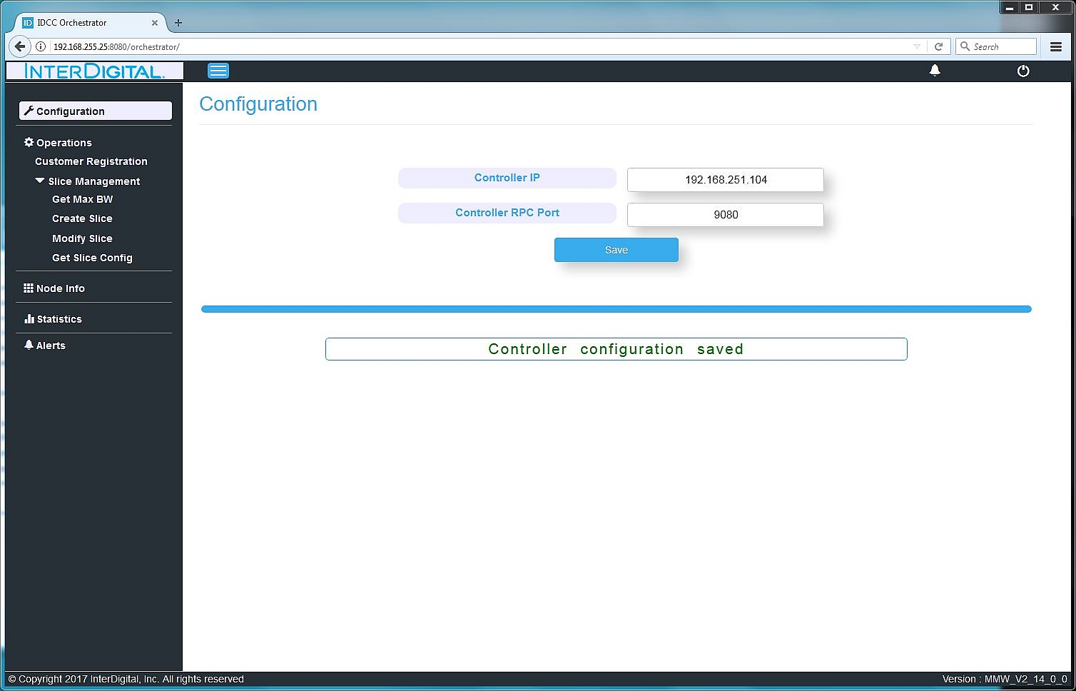

**Figure 1: Configuration**

Following values need to be entered and saved:

* NC IP : where ONOS is running
* NC RPC Port : port at which ONOS UI is accessed / at which ONOS HTTP REST interface is exposed.

## Customer Registration page

On this page, NBI session is created by registering the customer with NC. Without registering the customer, functionality on other pages remains disabled.

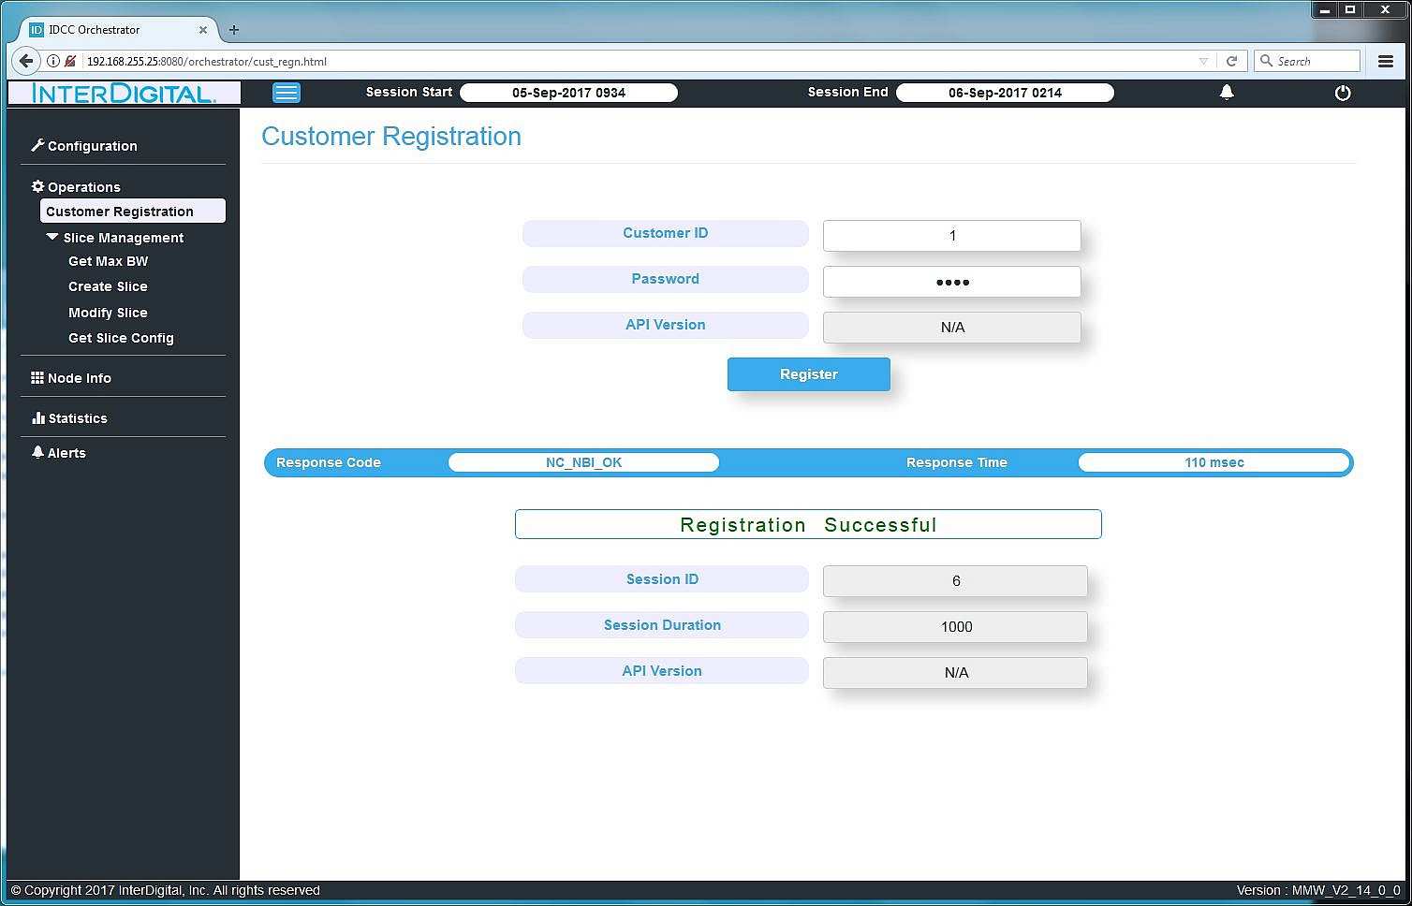

**Figure 2: Customer Registration**

Input fields are:

* Customer ID : ID of the customer
* Password : password of the customer
* API version : “N/A” \*

*\*The fields marked as NA in orchestrator cannot be written. These are fields that are not implemented on the NBI interface as of now and may become available in future sprints.*

Output values in NBI response from the NC to the RPC invocation are:

* Response Code : The status code of the RPC. Text interpreted by the orchestrator as per NBI ICD is shown in above figure as “Registration successful”. This text will vary as per the response code.
* Session ID : created by NC. Used internally on NBI between orchestrator and NC.
* Session Duration: Duration (in mins – as per ICD) until which this registered session remains valid after which orchestrator automatically deregisters the customer and re-registration is required.
* API version : NA

## Layout of a page

Layout of orchestrator pages is as shown in the figure below:

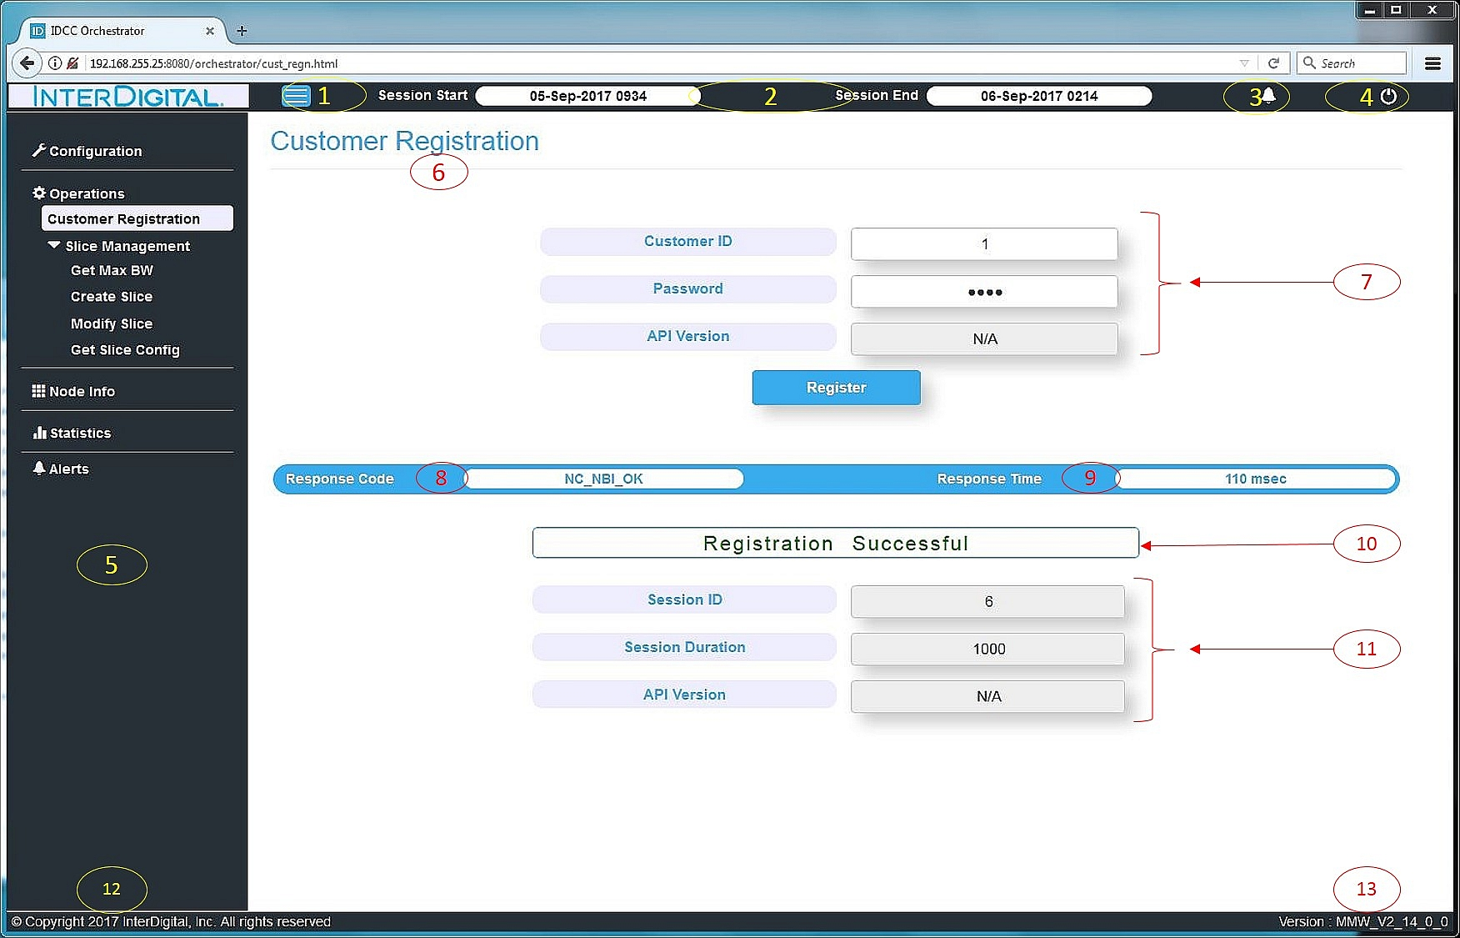

**Figure 3: Components in an orchestrator page**

The various fields as numbered in the figure are:

1. Button to toggle sidebar menu (field labelled #5 in the figure) visibility
2. Session start and end time (in format “DD-MMM-YYYY HHMM” (24 hrs)) calculated based upon the session duration value received in the customer registration nbi rpc response
3. Alert Icon – currently NA
4. Customer Deregistration button
5. Sidebar menu to navigate to the specific orchestrator page. Current page is highlighted. This sidebar menu can be shown/hidden using the field #1.
6. Title of the current page
7. Input fields specific to a page. The fields marked as NA in orchestrator are not implemented on the NBI interface as of now and may become available in future sprints.
8. Response Code – The HTTP REST API returns a return code as per NBI definition. This is interpreted by the orchestrator to display a status message (field labelled #10 in the figure)
9. Response Time – The turnaround time (in millisecond) between the HTTP REST API request initiated by the orchestrator and the response received back from NC NBI.
10. Status of the HTTP REST API – interpreted by the orchestrator based upon the response codes as defined in the NBI ICD e.g. “Invalid Session ID”, “Cannot meet SLA” etc.
11. Output fields – displaying the RPC’s response fields
12. The copyright text including the copyright year. The year can be manually updated during the orchestrator release build as in source code file orchestrator/js/idcc-version.js
13. The version of the orchestrator release. This is updated as per the labelling script during the release build process.

## Customer De-registration button

NBI session can be de-registered using the logoff button located on the top-right section of orchestrator pages.

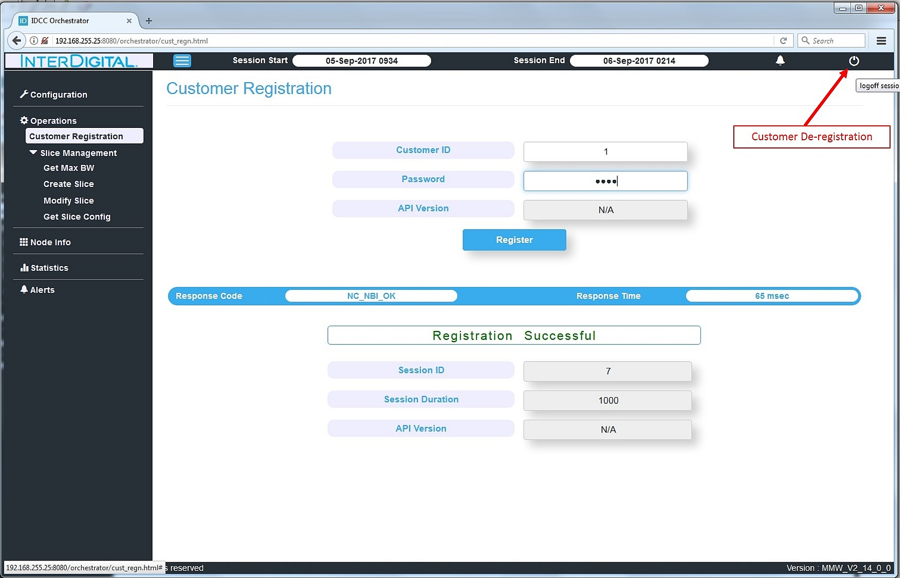

**Figure 4: Customer deregistration button**

On clicking the logoff button, the customer session details (session ID, session duration) are deleted from orchestrator memory even if customer de-registration RPC is unsuccessful.

RPC response code is shown in a pop-up.

## Get Node Info page

Before using the pages “Get Max BW” or “Slice Create”, operator needs to retrieve the information about mesh nodes via the Get Node Info page.

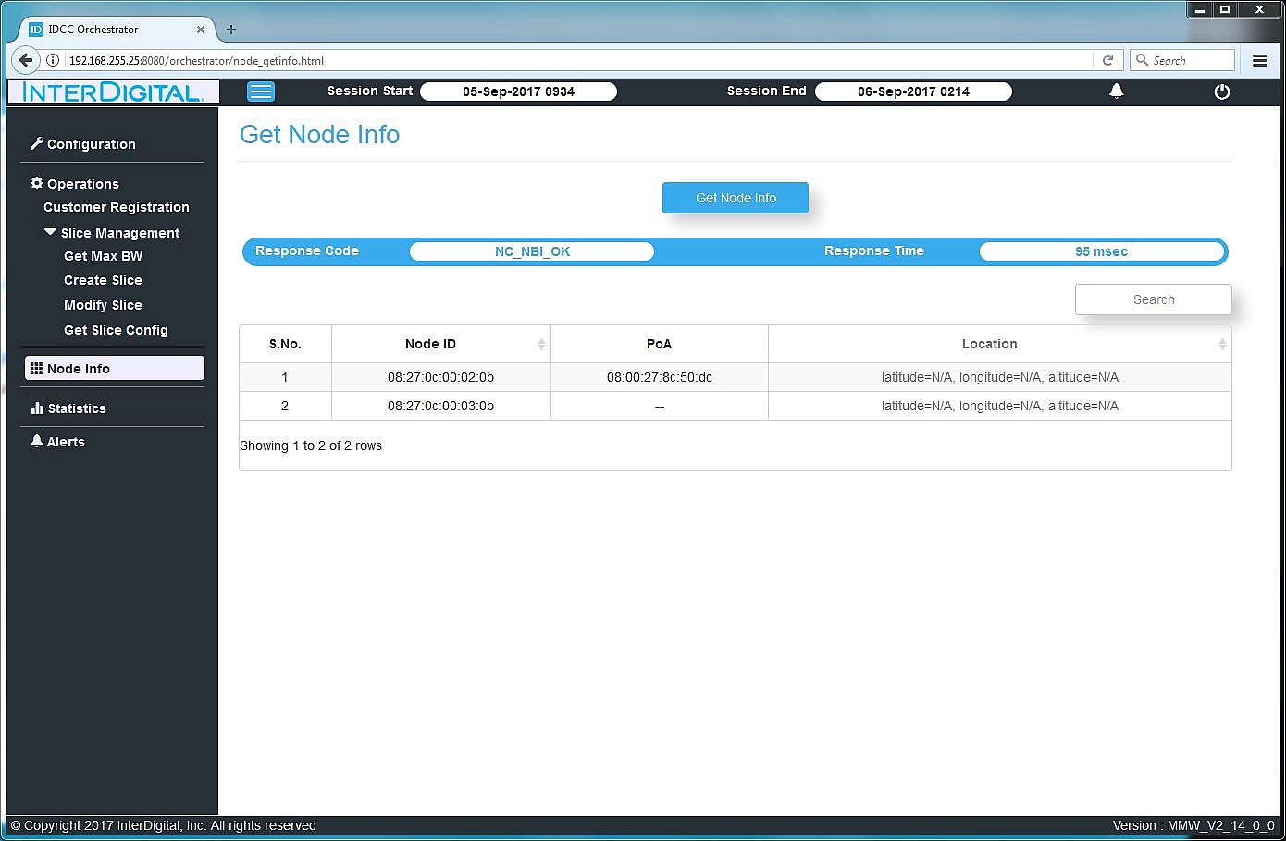

**Figure 5: Get Node Info**

Output values in NBI response from the NC to the RPC invocation are:

* Response Code : The status code of the RPC.
* Node ID : only the IDs of non-gateway mesh nodes connected in the network are returned in response and listed.
* PoA : The IDs of Points of attachment attached to the corresponding mesh node. If there are multiple PoA for a mesh node, they are listed in the same row as comma-separated values.
* Location : NA

## Get Maximum Available Bandwidth page

On this page, operator can retrieve bandwidth available on a mesh node (see Appendix 4.1 for details on Bandwidth allocation).

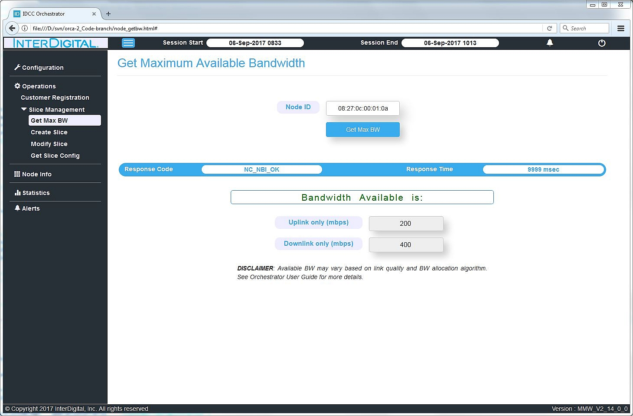

**Figure 6: Get Max Available BW**

Input fields are:

* Node ID : This is a dropdown menu to choose from the list of node IDs that were retrieved in the Get Node Info rpc.

Output values in NBI response from the NC to the RPC invocation are:

* Response Code : The status code of the RPC.
* UL only bandwidth available for the input node ID
* DL only bandwidth available for the input node ID

## Create Slice page

On this page, operator can create slices for a (node, POA) pair.

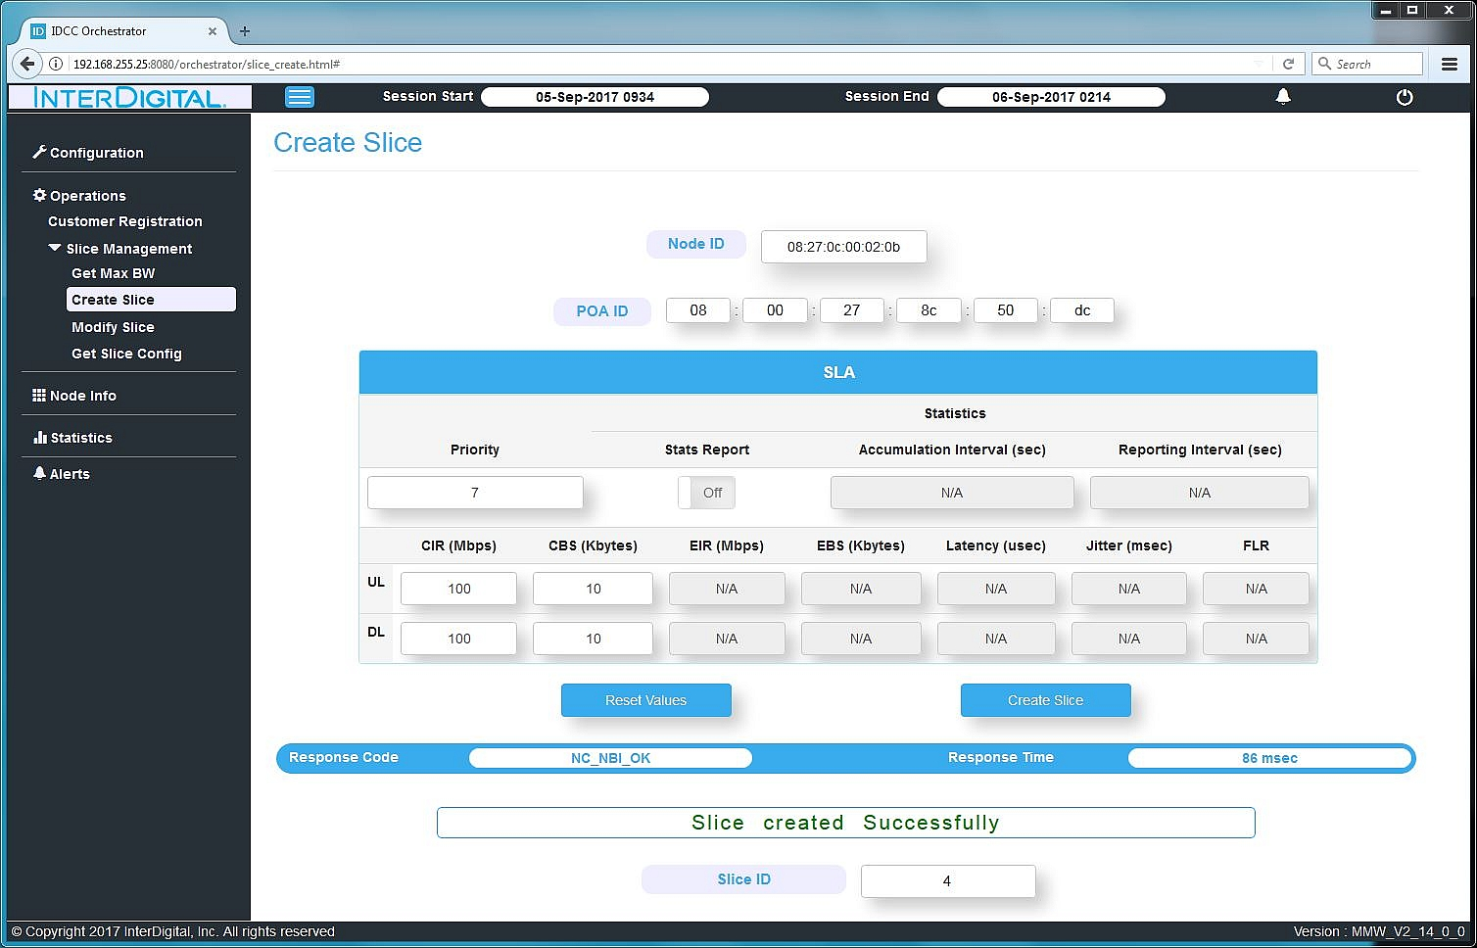

**Figure 7: Create Slice**

Input fields are:

* Node ID : This is a dropdown menu to choose from the list of node IDs that were retrieved in the Get Node Info rpc.
* POA ID : Mac address of the POA attached to the node ID chosen in the dropdown.
* SLA fields : Priority, CIR and CBS values can be input. Others are NA as of now.
* Note: The “Reset values” button merely clears all the input fields. Refreshing the page will repopulate the input fields with the values that were used before pressing reset.

Output values in NBI response from the NC to the RPC invocation are:

* Response Code : The status code of the RPC. Orchestrator also displays an interpreted text message.
* Slice ID as created by NC\*. This Slice ID can be used in Modify Slice page to modify the SLA values for that slice.

\*Slice ID enumeration as done by NC:

Slice ID for a flow is same as either the UL or DL VLAN ID of that flow. Static slices have pre-assigned IDs based upon the configuration of mesh NC done – these are the VLANs for the mesh nodes. NC then starts assigning IDs to each new dynamic slice in incremental manner beginning from the next available ID. As an example, let’s say NC is configured with following UL & DL VLAN IDs for the 3 mesh nodes in the network:

* node1 gw: VLAN IDs 1 & 2, node2 non-gw: VLAN IDs 11 & 12, node3 non-gw: VLAN IDs 21 & 22

In this case, the first dynamic slice (say for PoA attached to node2) will have UL & DL VLAN IDs as 3 & 4 and therefore the slice ID as returned in Create Slice RPC response to the orchestrator will either be 3 or 4.

## Modify Slice page

On this page, operator can modify SLA values (that are currently supported by NC) for a slice.

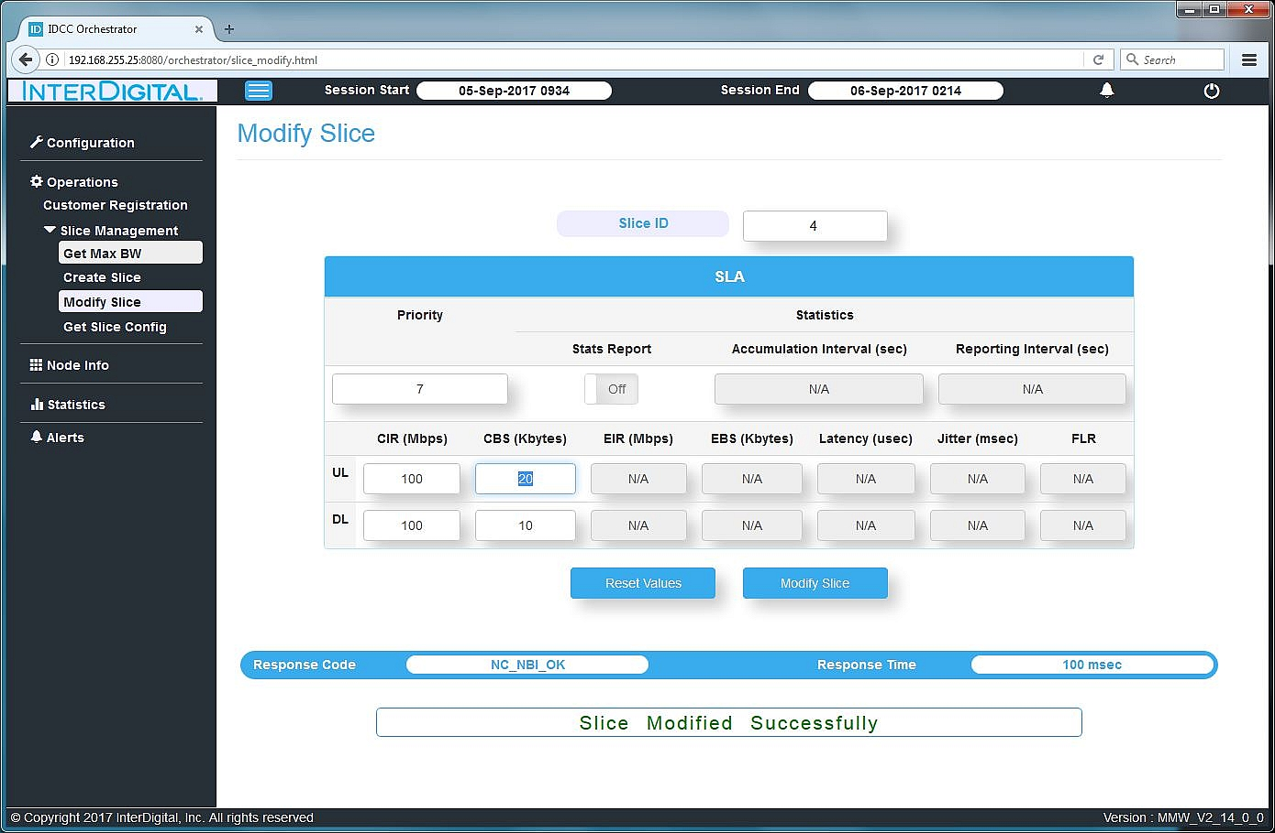

**Figure 8: Modify Slice**

Input fields are:

* Slice ID : The dynamic slice ID for which SLA values need to be modified. A list of slice IDs can be retrieved from the Get Slice Config page explained next.
* SLA values : same fields as in create slice page.
* Note: The “Reset values” button merely clears all the input fields. Refreshing the page will repopulate the input fields with the values that were used before pressing reset.

Output values in NBI response from the NC to the RPC invocation are:

* Response Code : The status code of the RPC. Orchestrator also displays an interpreted text message.

## Get Slice Config page

On this page, operator can retrieve list of dynamic slices (or a single slice), POAs for which they were created and SLA values corresponding to the slices.

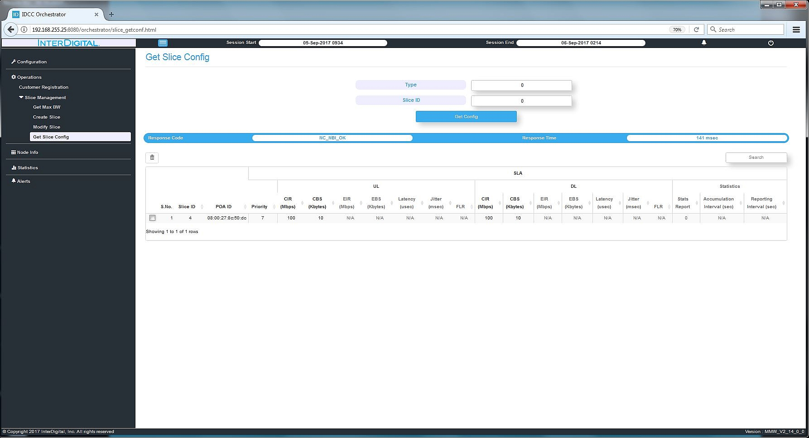

**Figure 9: Get Slice Config**

Input fields are:

* Type : Input 0 to retrieve a list of all dynamic slices. Input 1 to retrieve slice information for the slice ID mentioned in the slice ID input field.
* Slice ID : The slice ID for which information is to be retrieved. Note that this input value is honored by NC NBI only if Type input field value is 1; otherwise this slice ID value is ignored.

Output values in NBI response from the NC to the RPC invocation are:

* Response Code : The status code of the RPC.
* A list of all dynamic slices, POAs for which they were created and SLA values corresponding to the slices.

## Delete Slice button

On this page, operator can delete a dynamic slice.

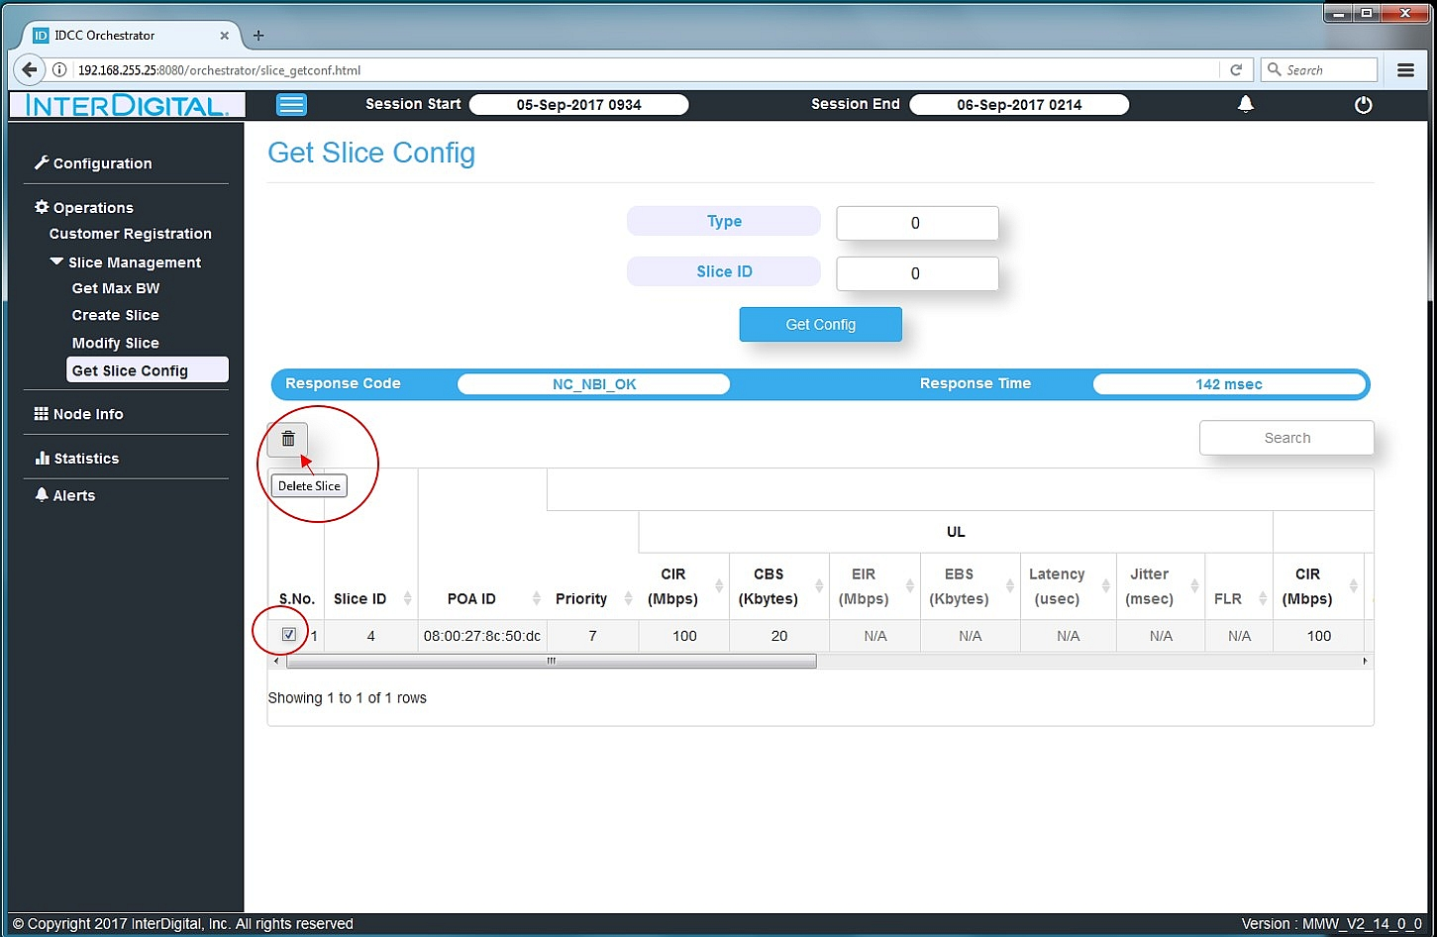

**Figure 10: Delete Slice button**

Once a list of slices (or a single slice) is retrieved on the get slice config page, operator can check the checkbox (as shown in figure above) and proceed to delete the slice by pressing the delete slice button (trashcan icon). Note that at a time only single slice can be selected for deletion.

## Read Statistics page

On this page, operator can statistics for a single or a list of dynamic slices(s).

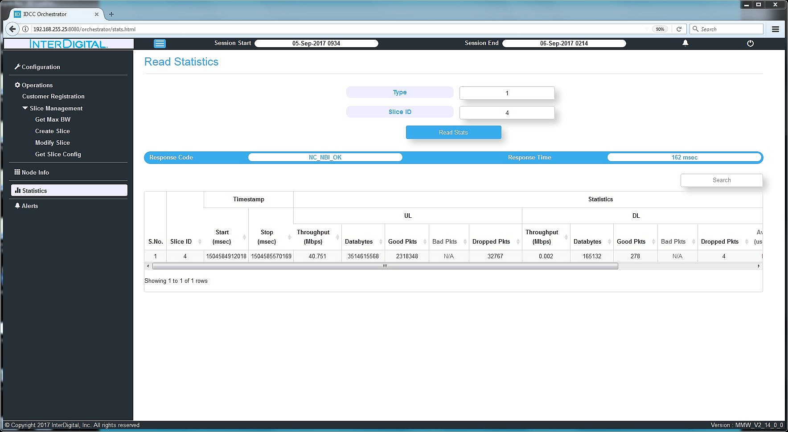

**Figure 11: Slice statistics**

Input fields are:

* Type : Input 0 to retrieve statistics for all dynamic slices. Input 1 to retrieve slice statistics for the slice ID mentioned in the slice ID input field.
* Slice ID : The slice ID for which statistics are to be retrieved. Note that this input value is honored by NC NBI only if Type input field value is 1; otherwise this slice ID value is ignored.

Output values in NBI response from the NC to the RPC invocation are:

* Response Code : The status code of the RPC.
* Statistics for the slice (or list of slices) as defined in the NBI ICD. These include the UL & DL throughput (mbps), good and bad packets etc.

# Appendix

## Bandwidth Allocation Design

Basic principles:

* Path calculation is not defined in this section, please refer to the path calculation algorithm section for details.
* Alternate paths reserve 100% of the bandwidth to guarantee the availability of alternates path if failures occur in the network.
* A primary path can be established even without having an alternate path, but this path will not survive a failure on a link within its path.
* Link quality is determined by the transmitter (also referred as MCS; the higher the MCS, the greater bits aggregation it has, hence the higher the throughout). A Link can have a different link quality in either direction, which impacts the amount of bandwidth used to transmit data. When the link quality in both direction is the same, the link is said to have symmetrical link quality.
* Maximum bandwidth allocation on a link is set to 80% of the link capacity to allow room for packets other than data packet to traverse the network (signaling, control, etc.)

The following table represents the maximum bandwidth that can be allocated based on this 80% of the bandwidth that is available to be allocated:

|  |  |  |  |
| --- | --- | --- | --- |
| MCS | Max data rate (Mbps) | MCS | Max data rate (Mbps) |
| 0 | 220 | 7 | 1540 |
| 1 | 308 | 8 | 1848 |
| 2 | 616 | 9 | 2002 |
| 3 | 770 | 10 | 2464 |
| 4 | 924 | 11 | 3080 |
| 5 | 1001 | 12 | 3696 |
| 6 | 1232 |  |  |

Table Maximum bandwidth allocation rate (Mbps) per MCS

* The system is using TDD (Time Division Duplex), where a single frequency is used for both transmit and receive operations are alternate between each other over time.
* Nodes support point-to-multipoint (single PCP to multiple STA) link establishment, but based on the TDD nature of the network, data sent over a link impacts the amount of data that can be sent from that same PCP to another STA as the transmission time is shared among the associated STAs of the same PCP.

### Bandwidth allocation on bidirectional link with symmetrical MCS

|  |  |  |
| --- | --- | --- |
|  | Link | BW allocated |
| 1->2 | 100MB |
| 2->1 | 100MB |

Table Bandwidth allocation on bidirectional link with symmetrical MCS

Table 1 shows two links but they should be interpreted as one link with 2 directions. Table 2 shows the results after bandwidth gets allocated.

|  |  |  |  |
| --- | --- | --- | --- |
| Link | BW available before | BW available after | Total BW allocated |
| 1<->2 | 2000MB | 1800MB | 200MB |

Table Resulting bandwidth.

### Bandwidth allocation on bidirectional link with asymmetrical MCS

|  |  |  |
| --- | --- | --- |
|  | Link | BW allocated |
| 1->2 | 100MB |
| 2->1 | 100MB |

Table Bandwidth allocation on bidirectional link with asymmetrical MCS

As per previous section, Table 3 shows two links but they should be interpreted as one link with 2 directions. Table 2 shows the results after bandwidth gets allocated.

|  |  |  |  |
| --- | --- | --- | --- |
| Link | BW available before | BW available after | Total BW allocated |
| 1->2 | 2000MB | 1700MB | 200MB |
| 1<-2 | 1000MB | 850MB |

Table Resulting bandwidth per direction

Although only 200MB were meant to be allocated, the available bandwidth after that allocation is significantly diminished. The link from 1 to 2 allocated 100MB at MCS 9, but the MCS 5 allocation in the opposite direction is using 200MB of the bandwidth that it would get. At MCS 5, the data rate is half of what it is at MCS 9, thus although 100MB is reserved, it the 2->1 direction, 200MB is used of the 1->2 direction. Same reason applies for the other direction.

### PCP with more than one STA (TDD impact on point-to-multipoint links)

|  |  |  |
| --- | --- | --- |
|  | Link | BW allocated |
| 1->2 | 100MB |
| 2->1 | 100MB |
| 1->3 | 100MB |
| 3->1 | 100MB |

Table Bandwidth allocation on bidirectional link on a point-to-multipoint connection

Table 5 shows a diagram on which N2 and N3 are connected to N1 through 1 PCP sector only to demonstrate the point-to-multipoint impact on TDD.

|  |  |  |  |
| --- | --- | --- | --- |
| Link | BW available before | BW available after | Total BW allocated |
| 1->2 | 2000MB | 1400MB | 200MB |
| 1<-2 | 2000MB | 1400MB |
| 1->3 | 1000MB | 700MB | 200MB |
| 1<-3 | 1000MB | 700MB |

Table Resulting bandwidth per direction

The results show that although only 200MB is allocated between N1 and N2, 600MB is used up. The reason being that 400MB is used on N1 in order to reserve 200MB for the link N1-N3 at MCS 5. The results can be used as proportions of the data rate. As such, when 100MB is reserved at MCS 9, it uses 5% of the available bandwidth(100MB/2000MB = 5%). At MCS 5, it represents 10% (100MB/1000MB = 10%). So if on one single sector like it is the case here, N1-N2 link will use 10% of the bandwidth while N1-N3 uses 20%. The total is then that 30% of the bandwidth that N1 can allocate is being used up. Which explains the results of table 6.

### Example of alternate paths bandwidth allocation

|  |
| --- |
|  |
|
|
|
|

Figure 12 Triangle topology example

Assuming the topology of figure 1 where links between N1-N2 and N2-N3 have MCS 9 and N1-N3 has MCS 5. N1 only has one sector which implies a point to multipoint configuration

At T=0, here are the available bandwidth per segment

|  |  |
| --- | --- |
| Link | BW available before |
| N1-N2 | 2000MB |
| N2-N3 | 2000MB |
| N1-N3 | 1000MB |

Table Available bandwidth at T=0

At T=1, a slice gets created for a POA connected on N2 requesting a bandwidth of 100MB in uplink and 100MB in downlink. Note that alternate routes are allocated at 100% of the bandwidth requirement which explains the results in table 8

|  |  |
| --- | --- |
| Link | BW available after T=1 |
| N1-N2 | 1400MB |
| N2-N3 | 1800MB |
| N1-N3 | 700MB |

Table Available bandwidth after T=1

At T=2, 2 more slices get created for POAs connected on N2 requesting a bandwidth of 100MB in uplink and 100MB in downlink each.

|  |  |
| --- | --- |
| Link | BW available after T=2 |
| N1-N2 | 200MB |
| N2-N3 | 1400MB |
| N1-N3 | 100MB |

Table Available bandwidth after T=2

At T=3, another slice (a fourth one) gets created for a POA connected on N2 requesting a bandwidth of 100MB in uplink and 100MB in downlink. Table 10 shows the result that an alternate path could not be allocated, so only a primary path between N1-N2 will be allocated and using the whole bandwidth that was left.

|  |  |
| --- | --- |
| Link | BW available after T=3 |
| N1-N2 | 0MB |
| N2-N3 | 1400MB |
| N1-N3 | 100MB |

Table Available bandwidth after T=3